**BLOOD BANK**

**MOBILE APPLICATION**

M.Tech CSE

BY

Ashwin Rishi P.J-(17MCS0085)

Anjani Gangavarapu-(17MCS0005)

Akhil Kumar reddy -(17MCS0052)



Table of Contents

CHAPTER 1 3

CHAPTER 2 4

2.1 EXISTING SYSTEM: 4

2.2 PROPOSED SYSTEM: 4

CHAPTER 3 5

3.1 SOFTWARE REQUIREMENTS: 5

3.2 HARDWARE REQUIREMENTS: 5

CHAPTER 4 6

4.1 MODULES: 6

4.2 ER DIAGRAM: 7

4.3 CLASS DIAGRAM: 8

# CHAPTER 1

INTRODUCTION

The Blood Bank mobile application project aims at maintaining all the information pertaining to blood donors, different blood groups available in each blood bank and help them manage in a better way. The blood donors can register to this system by entering their profile information. It Aim is to provide transparency in this field, make the process of obtaining blood from a blood bank hassle free and corruption free and make the system of blood bank application effective.

Blood Bank application can help to collect blood from many donors from various sources and distributed that blood to needy people who require blood. The project consists of central repository containing various blood groups deposit available along with related details. The details include that type, blood storage area and date of storage .This details helps in maintaining blood deposits.

These system also helps to keep records of patient name and contacts. The application uses the cloud system to store and retrieve the user information and details of the blood system. It has created with purpose of replacing all of paper work done at the blood bank

The main objective of these application is built in such a way that complete operation of blood bank and also searching should be fast so they can find require d details instantly, application built in such away that it should suit for all types of blood bank in future. These system helps to register all the donors, blood collection details, blood issued details etc..

# CHAPTER 2

PROJECT OVERVIEW

# EXISTING SYSTEM:

* In existing Blood Donation Application System, not all users can get access to the information because of the low working of the application or is not able to access any site.
* Sometimes the information is not updated or available for a particular place.
* In existing system the security is less and latest updates and uploads are not so frequent.
* Additionally, there is no donor details of the most blood bank systems.

# PROPOSED SYSTEM:

* In this system we are trying to implement a cloud database from a centralised system of blood bank application system of services.
* The system throughput and reliability can be increased with the help of cloud database which in turn helps in getting the customers to get their details much faster.
* Initially the application connects with cloud system with profile information and later updates with user blood type with each time he requests for blood.
* After the query statistics the cloud updates with the current status of the user information.
* The blood bank maintains all the information about the donor for easy access and since the data is in virtual storage it is easy to upload details of the system globally.
* The users like manger and registered customers can check into the available blood samples at hospitals and details of the same can be found.
* The blood bank also connects with the cloud system to update details so that the user may get contact.

# CHAPTER 3

RESOURCE REQUIREMENTS

# SOFTWARE REQUIREMENTS:

* OS-Windows XP or above.
* TOOLS-Eclipse (juno), NetBeans IDE 8.0.1,Xampp Control Panel.
* PLATFORM-Android SDK Framework.
* IDE- Eclipse, NetBeans.
* ANDROID EMULATOR- SDK Version 2.2 or Higher.
* BROWSER-Ie9.0.
* DATABASE-MySql.

# HARDWARE REQUIREMENTS:

* PHONE-An android phone or tablet.

# CHAPTER 4

SOFTWARE REQUIREMENT SPECIFICATION

# MODULES:

The following integrated software had the given modules:

**Blood Bank Manager:** They have the right to add all the details to the system such as blood groups availability, the quantity in which they are available, locations nearby and country a nd every details including the phone number of the location office as well.

**Donor:** Donor is the one who donates the blood. The information of all the donors is being maintained. So that in case of emergency when the blood is not available then asking directly to the donor to provide hid blood will help the people a lot.

**Hospital:** All the organizations along with the place in which they are located can be added into this module.

**Cloud:** The cloud stores the user profile information and blood bank manager can update the same to get the registered user details.

**Blood Bank:** The reports that are generated after issuing the amount of blood to the patient or the person who wants it, a report is generated showing that how much blood is being given and to whom it is given and details about the person.

**Blood :**  The blood samples collected are experimented and tested in the system of samples and then sent to the Blood Bank where all the information about the blood system are stored and their donor details are also saved for references.

**Donations**: Donations of the donor made are maintained to quick search of the donor details.

# ER DIAGRAM:

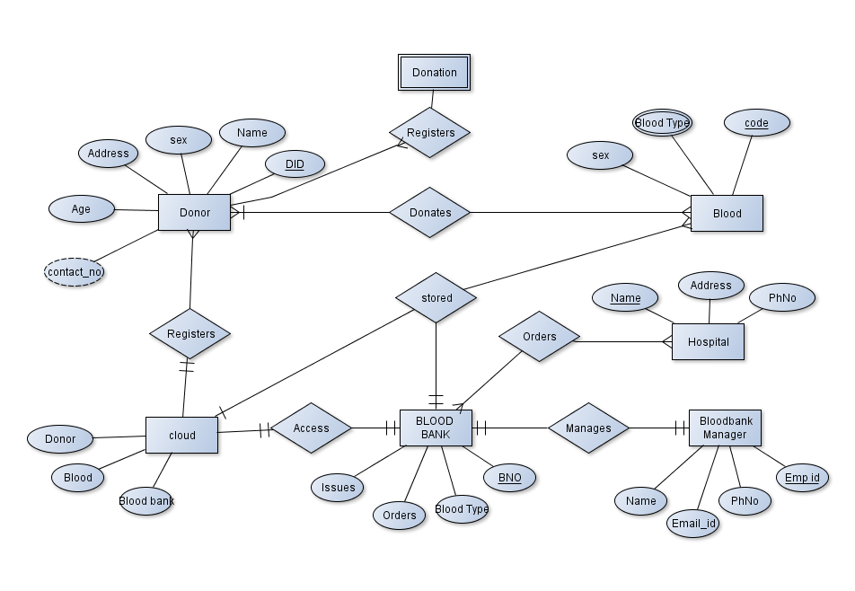

# CLASS DIAGRAM:

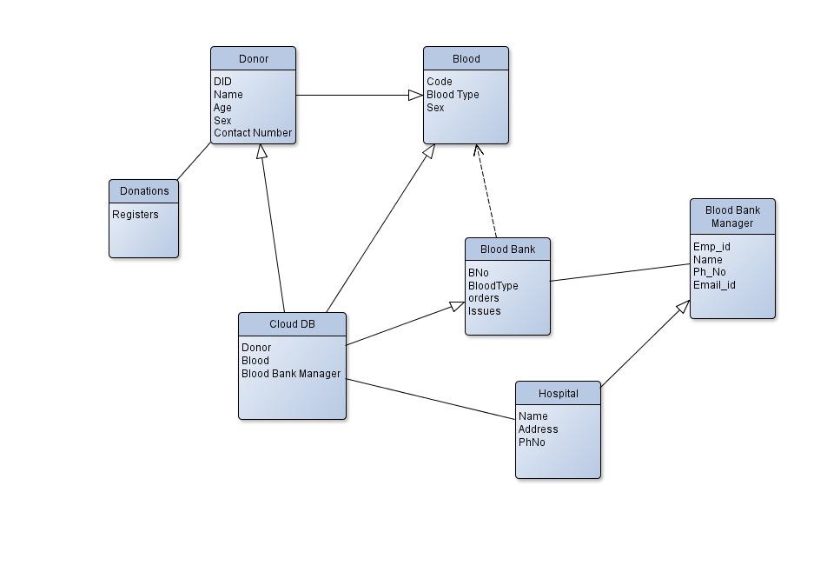

1. REFERENCES:

* [Vikas Kulshreshtha, 2011](http://www.sciencedirect.com/science/article/pii/S1877042815036940#bbib0005)Kulshreshtha Vikas , Maheshwari Sharad **“Blood Bank Management Information System in India”** International Journal of Engineering, 1, 2 (2011), pp. 260-263
* [Rational, 2012](http://www.sciencedirect.com/science/article/pii/S1877042815036940#bbib0010) Rational Unified Process, Best Practices for Software Development Teams. (2012).
* Referring online manual from website
* [www.codeproject.com](http://www.codeproject.com)
* [www.tutorialpoints.com](http://www.tutorialpoints.com)
* www.w3school.com